project (𝝿), select (𝛔), join (⨝)
Suppose we have the following 4 relations:
HOTEL (hotel_no, hotel_name, hotel_city)
ROOM (room_no, hotel_no, room_type, room_price)
BOOKING (hotel_no, guest_no, bdate_from, bdate_to, room_no)
GUEST (guest_no, guest_name, guest_address)
Write the relational algebra for the following queries (your answer must show an understanding of query efficiency i.e. you must not make use of unnecessary joins, nor carry attributes and tuples up through the query which are not necessary):
- List the number and name for all hotels
𝝿_{hotel_no, hotel_name}(HOTEL)

- List all single rooms with a price below $50
𝛔room_type=”single” ∧ room_price<50(ROOM)

- List the numbers and names of all hotels in Melbourne
𝛔_{hotel_city=”Melbourne”} (𝝿 (hotel_no, hotel_name, hotel_city(HOTEL))

- List all numbers and names of hotels which have a presidential suite room
𝝿_{hotel_name, hotel_no}(𝛔_{room_type=”presidential suite”}(ROOM) ⨝ HOTEL)

- List the price and type of all rooms at the Grosvenor Hotel
𝝿_{room_type, room_price}(𝛔_{hotel_name = “Grosvenor Hotel”}(ROOM) ⨝ HOTEL)

- List all numbers, names, and addresses of guests currently staying in deluxe room of any hotel (assume that if the guest has a tuple in the BOOKING relation, then they are currently staying in the hotel)
𝝿guest_no, guest_name, guest_address(GUEST ⋈ (𝛔_{hotel_type=”deluxe”}( ROOM⋈BOOKING)))

- List all numbers, names, and addresses of guests currently staying at the Grosvenor Hotel (assume that if the guest has a tuple in the BOOKING relation, then they are currently staying in the hotel)
𝝿guest_no, guest_name, guest_address (GUEST ⋈ ( BOOKING ⋈ (𝛔_{hotel_name = “Grosvenor”} (HOTEL))))

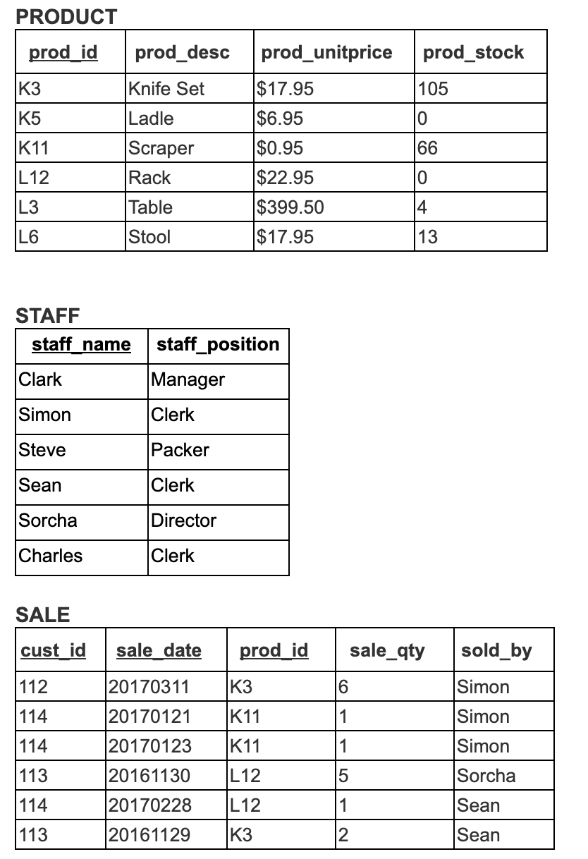
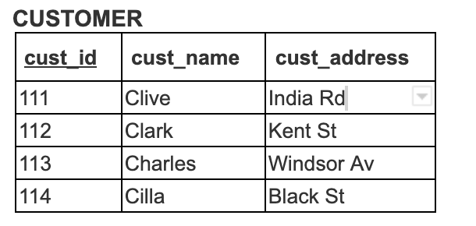
project (𝝿), select (𝛔), join (⨝)
Considers these four relations:
CUSTOMER (cust_id, cust_name, cust_address)
PRODUCT (prod_id, prod_desc, prod_unitprice, prod_stock)
STAFF (staff_name, staff_position)
SALE (cust_id, sale_date, prod_id, sale_qty, sold_by)
*Note that sold by value is the name of staff who made the sale
also refer to the following tables as seen in a RDBMS
Using Relational Algebra, answer the following queries. You must represent your answer in symbolic notation and where a query has several solutions, your answer must represent the most efficient solution.
- List ids, names of customers and descriptions of products bought by the customer. How many tuples will be returned by the relational algebra query that you have constructed as your answer?
𝝿_{cust_id, cust_name, prod_desc}(CUSTOMER ⨝ SALE ⨝ PRODUCT)

3

- List all names which are shared by customers and staff
𝝿_{cust_name}(CUSTOMER) ∩ 𝝿_{staff_name}(STAFF)

- List ids and descriptions of products that haven’t been sold
𝝿_{prod_id, prod_desc}(PRODUCT) – 𝝿_{prod_id, prod_desc}(SALE ⨝ PRODUCT)

- List names of clerks who don’t have any sales yet
𝝿_{staff_name}(𝛔_{staff_position=”Clerk”}(STAFF)) - 𝛔_{sold_by}(SALE)

- List categories (positions) of staff who have made sales
𝝿_{staff_ position}(STAFF ⨝(𝝿_{sold_by}(SALE)))

